Me and My Community – 1st Half Term
Beware the Bear – 2nd Half Term
Reception
Autumn 1
Rationale for Learning
This term we will focus settling the children into school, making friends and learning initial letter sounds.

Suggested activities for families to help support learning
Read regularly to your child.
Revise letter sounds as they come home – from week 4.
Hear your child read their school books.
Go on a teddy bears picnic.
Practice writing, saying and looking for focus sounds (phonics).
Look for numbers when you are out and about.
Visit the library.
Look for signs of autumn when you are out.
Key Vocabulary: Phoneme, diagraph, phonics, sound, letter.
Shapes- square, rectangle, circle, triangle, hexagon, quadrilateral, 2D.
Positional language- under, over, behind, next to, though, in front, on, off, inside, outside.
Topic words – doctor, nurse, paramedic, dentist, head teacher, caretaker, firefighter.

Reminders
Please do not play on the outdoor climbing equipment or any outdoor resources (bikes, playhouse etc.), before or after school.
Please remember to bring your red book bag with your reading book every day.
Please ensure your child has a PE bag with their colour house team top, red shorts, tracksuit bottoms/leggings and a jumper/tracksuit top and a pair of trainers.

Me and My Community
Beware the Bear
Study Unit Overview

Literacy
Learn the sounds- s a t i p n c k e h r m d g o u l f ll ff ck
Practise writing our names.
Listen to stories about people who help us and bears and find out information about these subjects.
Physical Development
Learn to travel in different ways- forwards, backwards, sideways.
Learning to use outdoor equipment safely and confidently.

Communication and Language
Discussing our family and interests using the treasure boxes we have made.

Understanding the World
Learn location of school features.
Draw a map.
Learn about people in the community.

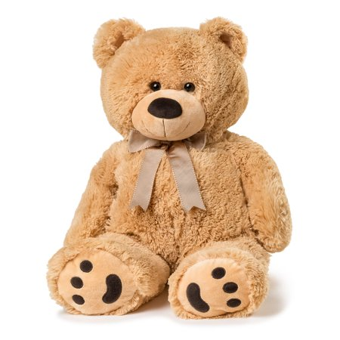
Mathematics
Focus on numbers 1, 2, 3 and 4.
Begin to look at 2D shapes- name and describe.
Use positional language to describe.
Expressive Arts and Design
Paint our self-portrait.
Build dens.
Paint bears.
Personal, Social and Emotional Development
Learn names of children in our class.
Learn the class rules
Take turns.
Learn to share.

