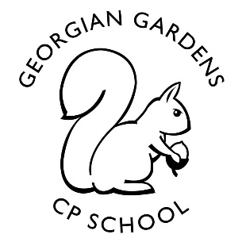
To Infinity and Beyond!
Year 5
Autumn 2021

Rationale for Learning
This term we shall be focusing our learning on space, the universe and the solar system. We shall be developing our scientific skills to research, identify and understand the planets and their features. We shall be completing a range of experiments to help the children learn about forces of gravity, air resistance, friction and centrifugal forces.
We shall be using a range of non-fiction books and technology to support our research and learning.
Suggested activities for families to help support learning
Regular times tables practice up to and including the 12 times table – everyone should have a log in for Times Table Rock Stars.
Every child should be reading at home for at least 15 minutes every day. Children still enjoy being read to so try to allow some time for this regularly. An audio book at bedtime or in the car is a great way of listening to a wonderful range of books.
There are so many fascinating things to learn about space. We enjoy hearing new facts that the children have discovered in their own time and would love to display them on the walls in the classrooms, so send them in!
Homework will be set weekly via SeeSaw on a Monday (from week 4) and should be uploaded by the following Monday. It will be responded to during week. The children will be set a short maths and English task in addition to regular reading and times table practise.
Key Vocabulary: solar system, planet, the sun, moon, stars, galaxy, universe, gravity, orbit, asteroid, meteorite, gases, Mercury, Venus, Earth, Mars, Jupiter, Saturn, Uranus, Neptune, dwarf planet, satellite, vacuum, comet, astronaut, space shuttle.
Reminders
P.E is on a Tuesday and Thursday. Please remember to send in jogging bottoms and a jumper for outdoor PE, as we will be heading out side, even when the weather gets colder.

We are planning a topic related trip for later in the term, more information will follow soon.

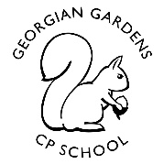
To Infinity and Beyond!
Study Unit Overview
Mathematics
Place value – including decimals to 2dp and negative numbers
Addition and subtraction
Multiplication and division
Area and perimeter
Statistics
Art
Planet art with water colours
Studying the work of Peter Thorpe and recreating pieces in his abstract style

Computing
Research and publishing
Digital literacy basics
We are game developers

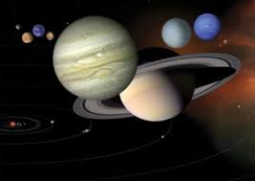
RE
Sikhism
Hinduism
Christianity

English
The features of the Sci-fi genre
Writing Sci-fi stories
Non-fiction research and writing
Space Poetry
Newspaper Reports

Geography
Using digital mapping technology
The Earth

Music
Planet Raps
Composing and performing a piece of music inspired by Holst’s Planet Suite and a focused planet study carried out in science.
PE
Running
Hockey
Tag Rugby

E4S: Education for Safeguarding
Worries
Empathy
Self Esteem and Wellbeing
Online Safety and Behaviours

French
Conversations including introducing ourselves
Greetings
Core vocabulary: Days / Months
Science
Earth and Space
Research Skills
Investigation Skills
Forces
Light

