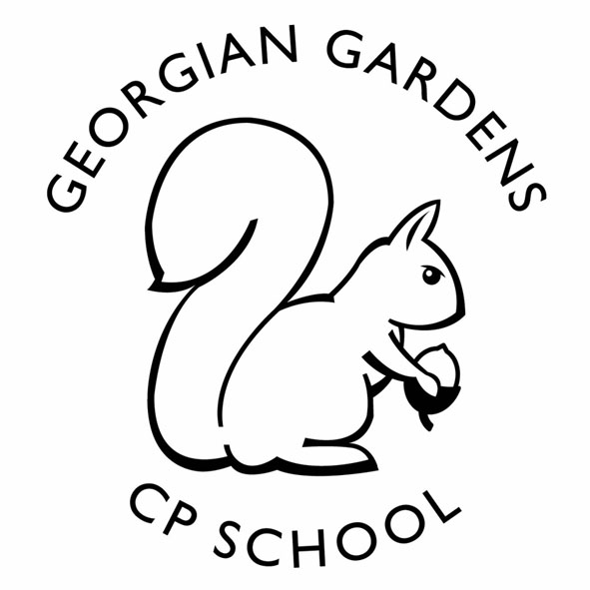
Parent/Carer Consent/Payment

Year 5 trip to South Downs Planetarium
on Wednesday 23rd November 2022

Section 1. Parent/Carers Consent

I give permission for to take part in the above-mentioned visit, and having read the accompanying letter, agree to his/her taking part in any or all of the activities described.

I have ensured that my child understands that it is important for his/her safety and for that of the group, that any rules and instructions given by the staff in charge are obeyed.

Please delete and complete the following as appropriate:

My child has (a) no illness, allergy or physical disability*
(b) the following illness, allergy or disability*

………………………………………………………………………………………………………………………………………………………………………

which requires the following treatment …………………………………….…………………………………………………………………
(please use separate sheet if necessary)
………………………………………………………………………………………………………………………………………………………………………

I consent to any emergency treatment necessary during the course of the visit.

Signed ………………………………………………………………………….………………………………………………………. (Parent/Carer)

Please give a contact name and telephone number where we can reach you on the day (if necessary).

Name ………………………………………………………………………………… Telephone Number ………………………………………..

……………………………………………………………………………………………………………………………………………………………………………

Section 2: My child is in receipt of Free School Meals and I would like the school to provide a packed lunch – please tick the appropriate box.

My child will have the packed lunch provided by school.

My child will be bring their own packed lunch.

* Please delete as necessary

