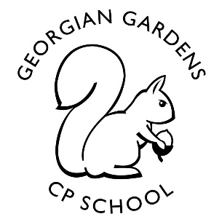
Digging Up The Past
Year 6
Autumn term

Y6 staff
Mrs Fookes, Miss Petfield, Mrs Smith, Mrs Allen, Miss Donovan

Rationale for Learning
To develop a better understanding of Britain’s past and how it has changed from the Anglo-Saxons period through to the Vikings.

Suggested activities for families to help support learning
- Encourage and support homework activities and the importance of organisational skills and dead lines
- Share fiction and non-fiction books with your child
- Look at how life has changed from the past (positives and negatives)
- General times tables (TTRS)
- Spellings (Y5/6 spelling list)

Key Vocabulary: influenced, significance, interpretation, civilization, empire, evidence, changes, relationships, diversity.
Reminders
- P.E. clothes at school every day.
- Labelled drink bottles in school every day (water please).

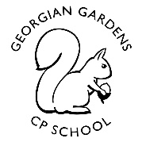
Digging Up The Past
Study Unit Overview
Art
Pencil sketches
Photography
Batik
Printing
Mathematics
Number and place value
Addition and subtraction
Geometry
Measure
Roman numerals
Computing
Digital literacy revision
Algorithms

RE
Islam – beliefs and practices
Christmas

English
Character description
Retelling stories
Instructional writing
Viking diaries
Poetry
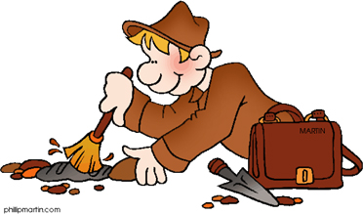

Add Picture
Music
Charanga scheme
Science/Design Technology
Scientific inquiries
Identify and name the main parts of the human circulatory system, and describe the functions of the heart, blood vessels and blood.
Shield design
Viking based activity

PE
Outdoor and adventurous activities
Fitness

French
Greetings
Conversations
Routines

E4S
Class contract – respecting others
How emotions make us feel
Democracy – Young Governors and house elections
Black history month
Choices/anti bullying/diversity
Geography
Name + locate world countries
Changes to Geography over long periods of time (map work)
Digimaps

History
Changes in Britain/time lines
British resistance
Culture and beliefs
British settlements – invasions, place names, village life, art and culture…

