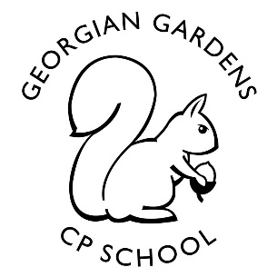
Tour of Britain
Year 3
Autumn Term 2021

Rationale for Learning
This term’s learning focus is based around Wally taking his tour of the different counties of the United Kingdom and looking at how diverse the UK is.
Suggested activities for families to help support learning
Enjoy working out the answers to Wally’s clues about where he has visited. (Remember there are more rewards for extra bonus facts.)
Practise telling the time on both the analogue and digital clock.
Begin to practise times tables.
Enjoy reading and taking quizzes using our Key Stage 2 Accelerated reading scheme. These quizzes are currently only available in school.

Key Vocabulary:
Practise the year 2 spelling list. Begin to learn to read and recognize the year 3 / 4 spelling list. Talk about the spelling and meaning of the words direction, compass, county, country, continent, village, town, settlement, hamlet, city, map, route, North, East, South and West.

Reminders
Our PE day will be on Tuesdays (As part of our PPA) and every other Wednesday outside. Please ensure that your child has outdoor PE kit in school EVERY DAY, there are many reasons a spare set of clothes could be useful.
An old T shirt / apron for art is also useful.
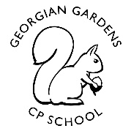
Year 3 Autumn 2021
Tour of Britain
Mathematics
Number and place value. Numbers up to at least 1000.
Addition and subtraction including compact method and partitioning.
Multiplication with a focus on times tables. Up to 10x10.
Division as sharing with whole numbers.
Position and direction, compass points and algorithms.
Money, pounds and pence.
Time, analogue and digital to the nearest 5 minutes.
Art
Self-portraits.
Pop art.
Posters/advertising.
Christmas craft.

Computing
Learn how to look after your password.
Using Scratch programming to control characters on a screen.
Begin to fix bugs on a scratch programme.

RE
Awareness of different cultures and religions in Britain.
British patron saints.
The Christmas story.

Add Picture
Science
Forces, what is a push? What is a pull? Where can these forces be located on a human skeleton and beyond.
Look at the skeleton and learn some facts about the bones and joints in our body.
Magnets, how they work and are used.

Music
Different types of British music.
British traditional music and anthems.

PE
Ball skills
Multi skills

E4S
Rules and routines.
Similarities and differences.
Respect.
Communities
Firework safety
French
Counting, colours and Christmas

Geography
Geographic features of maps of village/town/county/country/continent.
Labelling
Locating features on OS maps.
Describing features-physical and human.

English
Poetry, ‘We are Britain’ learn by heart, and perform. Use the style to create own poems.
Multicultural stories as a stimulus for writing using your senses to add description.
Research and fact finding about UK landmarks.
Tourist information, improve a badly written example.
Story writing.

