Marking and feedback guidelines
‘Formative marking involves telling pupils what they have achieved and also what needs to be done to improve, in relation to the learning intention and/ or the individual targets’.
It is important that we have a whole school approach to Marking and Feedback, which is clear to everyone including children, parents/carers, visitors and supply teachers

Aims and objectives of Marking & Feedback

Marking & Feedback underpins the whole assessment process. A common approach throughout the school will benefit record keeping and assessment procedures. This will enable teachers to make informed judgements regarding individual/group or class cohorts.

- Marking & Feedback is an important aspect of the daily contact between the adult and the child.
- It is also a powerful monitoring tool for presentation, assessment, quantity and quality.
- Marking & Feedback shows that we value children’s work and effort.
- It should be done with the child wherever possible
- It should be a positive and developmental exercise and criticism should be constructive.
- All stakeholders have ownership of Marking & Feedback.
- As a school, we value written and verbal feedback equally.

Marking Guidelines

When marking children’s work staff should apply the following guidelines:
- Marking is most effective whilst the pupil is completing the work as it gives them a chance to respond and take on advice offered.
- All written work should be marked with a minimum of a tick to signify children’s work has been looked at.
- Some written work should be quality marked (marked in greater depth).
- Where work is quality marked, comments should generally relate to the learning objective.
- Quality marking should contain at least one positive comment and provide an area
for development.
- Work should not be over-marked.
- All work should be marked using the agreed Marking Codes (within a key stage).
- Marking should be neat and legible – Using pink for praise and Green for growth.
- Marking should be diagnostic and repeated mistakes should be analysed carefully.

Marking and feedback guidelines

- Children should be given regular opportunities to reflect upon and respond to marking, orally and in writing.
- TLAs/supply teachers/PPA teachers should follow the policy and indicate if they have marked a piece of work with their initials.
- Marking could/should be tied into our rewards system.

Marking of mathematics
- If one part of a calculation or procedure is incorrect, a circle is used to indicate the error and the correct procedure written alongside the work, as an example.
- All children are encouraged to revisit their piece of work and check for feedback.
- Use ‘√ ‘for correct workings and ‘•’ for incorrect workings.

Marking of writing
- All pupils should be encouraged to proof read and edit all their own work for spelling, grammar and punctuation (purple polishing pens).
- Spelling punctuation and grammar errors must be marked and corrected according to the learning intention and the individual child’s ability. It is not helpful to correct every mistake in every piece of work, particularly with younger and less able children. If work is corrected it should be done using the attached marking codes for KS2 and assessment criteria for KS1.

Marking of work that is not in a written form
- Teachers must constantly assess progress in reading, speaking and listening, social skills and PE and provide verbal feedback.
- Some learning requires verbal communication during the process and evaluation at the end to highlight and clarify strengths and areas for development. Photographic evidence may be used in these instances.
- In foundation subjects work must be marked against the learning intention for the lesson and not always for spelling grammar and punctuation.

“The best marking occurs when the child is still working on a piece and the impact of the marking can be seen within the rest of the work (Mid-marking)”

What does the most
effective feedback look like?

A misconception is picked up in marking

The child acknowledges this marking

There is evidence in a future piece of work that this has been addressed

The marker responds with positive praise related to the specific progress made

Marking codes

Assessment strips – YR & KS1 writing

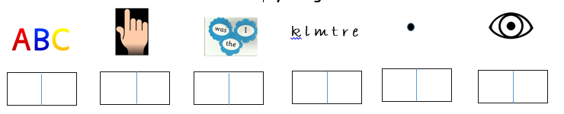

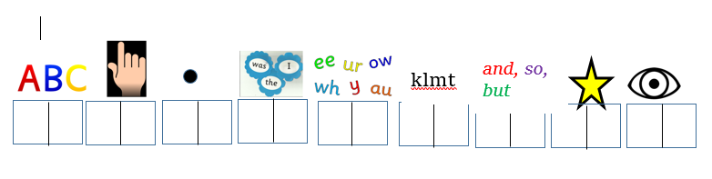

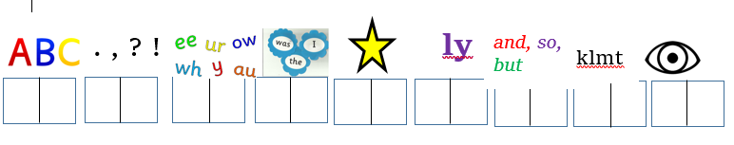
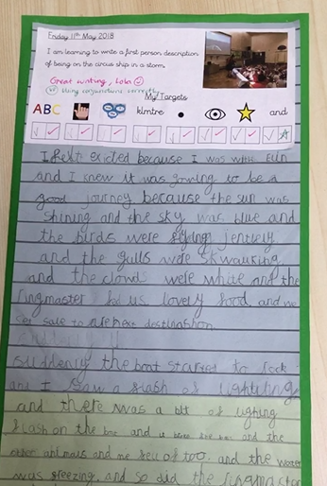

There are a range of assessment strips that we have created to support the development of writing in YR & KS1. These can be found on the staff server under KS1 assessment slips and should be used to support marking of all focussed writing pieces.

Marking codes

Marking Code KS2

Missing capital letter—circle incorrect letter
Incorrect spelling—underline incorrect word
Incorrect punctuation—circle missing punctuation
Write / in the correct location to signify new line
Write // in the correct location to signify new paragraph
Write ^ to show that a words is missing
VF = verbal feedback A = adult assisted
I = independent work G - paired or group

