Title: It’s A Kind of Magic
Year group: Year 4
Autumn Term 2021

Rationale for Learning
Understand how the states of materials can change.
Understand how to create electrical circuits.
Understand how steam trains made changes in Britain.

Suggested activities for families to help support learning
Practise of times tables up to 12 x 12.
Reading on a regular basis for at least 15 minutes per day and completing quizzes on Accelerated Reader.
Research linked to current topic work.
Key Vocabulary: solids, liquids, gases, evaporation, condensation, circuit, wires, battery, current, switch, motor, light, bulb, steam, train, engine

Reminders
PE will usually be on Tuesdays and Thursdays for both classes, but please ensure PE kit is at school every day.
PPA for class teachers will be on a Tuesday each week.

Dates (specific to year 4)
Harry Potter Day – Children welcome to dress up (more details to follow)
A trip of some kind – TBC
Swimming lessons to start - TBC

Title: It’s a Kind of Magic
Study Unit Overview
Art
Drawing – line drawing techniques. Shading, hatching, contouring, and stippling.
Recreating pictures from a text using above techniques.
Self-portrait drawing using above techniques
Collage – creating art through collage.

Mathematics
Place Value – in 4 digit numbers
Compact addition and subtraction methods
Drawing and sorting shapes
Time to the nearest minute
Formal written methods
Fractions

Computing
Scratch – programming and coding
Using the internet safely

English
Letter writing
Writing about mythical beasts
Descriptive writing
Poetry writing
Diary writing

RE
Buddhism
The Buddhist way of life and what we can learn from it

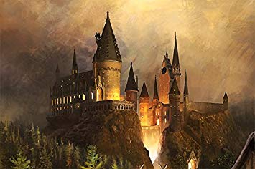
E4S Education for Safeguarding
How to be Ready, Respectful and Safe.
Keeping ourselves safe and well, physically and mentally.
Our online selves and staying safe online.
Growing up.

PE
Invasion Games – Handball
OAA
Dance
Multi Skills

Music
Listen with attention to detail.
French
Greetings, general conversations and language to describe ourselves.

Science
To compare and group materials into solids, liquids and gases.
Observe that some materials change state.
Identify the part played by evaporation and condensation in the Water Cycle.
Electricity, circuits, and creating a robot.

