Ocean Adventures
Year 2
Autumn Term
Rationale for Learning
Understanding of the impact of plastic to the creatures in the ocean, using David Attenborough as a role model. Visits to the beach in our local area will emphasise the issue surrounding plastic pollution.
Use of quality texts to support the teaching of the oceans and continents, to ensure the children have a secure geographical knowledge.

Suggested activities for families to help support learning
Regular reading at home, with completion of the reading diaries.
Completion of homework on a weekly basis (after October half term).
Visits to the beach.
Discussion and research to help support learning.
Securing number bonds to 10 and 20, counting (practically!), recognising numbers when you’re out and about!
Key Vocabulary: oceans (Atlantic, Pacific, Indian, Southern, Arctic), explorer, voyage, plastic, pollution, continents (North America, South America, Antarctica, Europe, Asia, Africa, Australia).
Reminders
PE days – Wednesdays and Thursdays.
Homework will be set on a Friday and will be due in on the following Thursday.

Dates (specific to year 2)
Beach visit – Wednesday 22nd September (morning only). We are hoping to have additional beach visits as well, weather dependent tbc.
Nativity tbc.
Ocean Adventures
Study Unit Overview
Music
Songs in Nativity.
Phonics songs.
Geography
Identifying the continents and oceans.
PSHCE
Friendships and relationships.
How to be a good learner (growth mindset).
Science
Animals including humans – impact of sea creatures in the oceans and how plastic pollution takes effect.
Notice differences between animals and humans, and their young.
Technology
Sewing skills on binka.
Design, make and evaluate a sea creature puppet.
English
Discrete SPAG teaching.
Flotsam – what the camera saw: a text with no words, using pictures to infer detail and using descriptive language.
Shackleton – diary writing from a character’s perspective.
Mathematics
Place value and number skills.
Adding and subtracting 10.
Money and measure.
Fractions – halves and quarters.
Shape and data.

Art
Creating sea creatures using key skills.
Sea collages
Patterns using shades of blue.
Underwater scenes using watercolours.
PE
Dance through the Nativity.
Participate in team games, developing simple tactics for attacking and defending.
Computing
Scratch to create underwater scenes using a range of sprites.

RE
The Christmas Story combined with the Nativity.

Phonics
Daily sessions on digraphs/trigraphs using Song of Sounds.
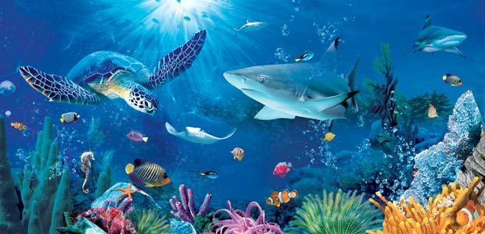
Add Picture

