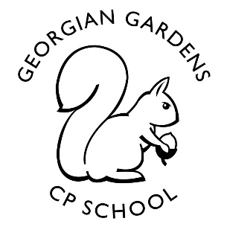
Up, Up and Away!
Year One
Autumn Term 2021
Rationale for Learning
Our topic has a Science focus. The children are going to be learning about different things that fly – kites, aeroplanes, hot air balloons and flying animals. They will be designing and making their own kites which we will fly on the school field. During the second half of the term, the children will find out about superheroes, both fictional and real life. They will learn about the parts of the body and senses. Engaging books will be used as the stimuli for the children’s learning. Many cross curricular links will be made.
Suggested activities for families to help support learning
Please read regularly with your child. Use the Phonics sounds in the reading record book to practice them too.
Practise counting objects, reading and writing numbers to 20 and beyond.
Practise counting forwards and backwards to 100 and beyond.
Help your child recognise numbers when you are out and about such as number plates, door numbers, road signs etc.
Talk about telling the time using an analogue clock – focusing on o’ clock and half past times.
Key Vocabulary:
Topic – fly, balloon, kite, aeroplane, helicopter, bird, owl, superhero, travel, airport, rocket, drone
Maths – count, forwards, backwards, more, less, equal, how many, greater, fewer, addition, subtraction, tens, ones
heavy, light, big, small, tall, short, measure,
English – letter, sound, phoneme, digraph, trigraph, sentence, full stop, capital letter, finger space
Reminders
PE is on Tuesday and Wednesday but please ensure named PE kits are in school every day. As it is the Autumn term, the weather is very changeable and therefore please can you provide your child with a winter kit (tracksuit bottoms and a jumper).
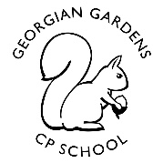
Up, Up and Away!
Study Unit Overview
Mathematics
- Place value and number sequences
- 2D shape
- Addition and subtraction – numbers to 20 and beyond
- Measuring
- Fractions, position and movement
- Counting to and across 100
- Counting in twos, fives and tens
- Number bonds to 10 and 20

Computing
- Using the laptops
- Ipads
- Beebots
- Internet safety

Art/Music
- Autumn art
- Hot air balloon art effects
- Painting skills and techniques
- Flying animal portraits
- Autumn sounds and how they can be recreated
- Singing and performing

E4S (Education for Safeguarding)
- Keeping safe at school
- New Beginnings and making choices
- Classroom rules and routines
- Anti-bullying
- Our school rules – Ready, Respectful and Safe

RE
- Creation stories
- Christmas
Geography/History/Design Technology
- Learning about things that fly – kites, aeroplanes, hot air balloons and flying animals
- The history of flight and flying machines
- Designing and making kites and flying machines
- The United Kingdom

Science
- Investigating flight
- Flying animals
- Describing, comparing and sorting animals
- The human body – naming, drawing and labelling body parts
- Senses

PE
- Multi-skills and fundamentals
- Gymnastics
- Fitness and keeping healthy

English
- Reading and sequencing stories
- Acting out stories
- Reading, following and writing instructions
- Researching flying animals using non-fiction texts
- Reading and writing poems
- Superheroes stories
- Revising the phonics taught in Year R
- Learning Year 1 simple rules
- Using simple punctuation in writing
- Learning to read and spell Year One tricky words

